**Airbnb Business Case Study**

**Business Understanding:**

* Airbnb has seen a major decline in revenue due to COVID-19 pandemic, now since people have started to travel more Airbnb wants to make sure that it is fully prepared for this change.

**Exploratory Data Analysis:**

* Checked the Null values in the dataset. Found some columns with the null values i.e. names, host_name, last_review, and review_per_month.
* Checked the outliers in the dataset.

**Data Analysis-**

* Try to analyse the data using different columns on the basis of their price, availability_365, minimum_nights and the reviews of the customers we received.

**Handling Missing Values:**

* Last review and reviews per month have 20% missing values, we can drop them so that it won’t Impact the Analysis.

**Data Analysis and Visualization:**

* Analysis is done based on Customer Preferences i.e., Room Type, Prices and Regions to get Insights which will be useful for the Business in Post Covid Period.

**Data Understanding:**

* There are 16 Variables in the Data of which 10 are Numeric Columns, 5 are Categorical and 1 is a Date column.

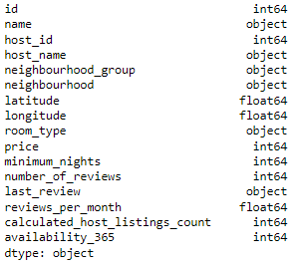

**Cleaning the data:**



**Data Analysis and Visualization:**

* Analysis is done based on Customer Preferences i.e., Room Type, Prices and Regions to get Insights which will be useful for the Business in Post Covid Period.

**Customer Preferences of Room Types:**

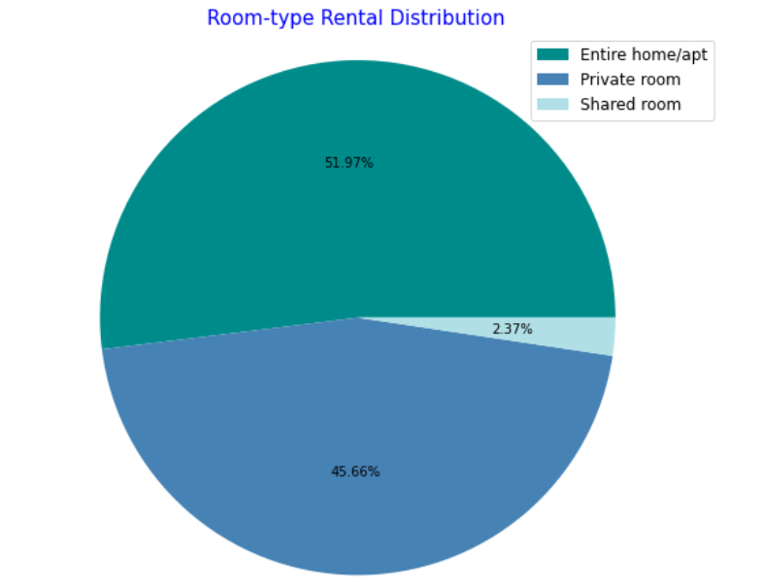

**Inference after analysing the data -**

* We saw that people like to visit the centre of New York from where they can see the beauty of the city.
* Number of listings of shared rooms are limited but their average price is placed less and availability is high.
* Number of reviews and reviews per month are more at less price than the higher price as there is less chance of people going for a high price room.
* Manhattan and Brooklyn are very costly neighbourhood groups.
* People show interest in the host blue ground, and spend more nights here.
* Minimum number of nights to stay reduces with increase in price.
* Focus on prime locations like Manhattan and Brooklyn where people show interest.

**Tool used for Data wrangling:** Python

**Tool used for Binning and Visualization**: Tableau 2021.3